**Work Order**

**Technical MANUAL**

1. Login to Admin account.

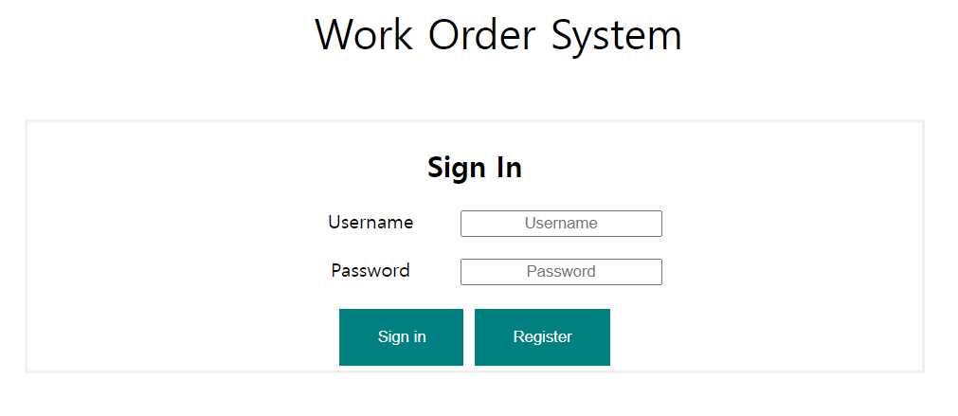

* 1. Go to incident list

* 1. Press the Edit incidents

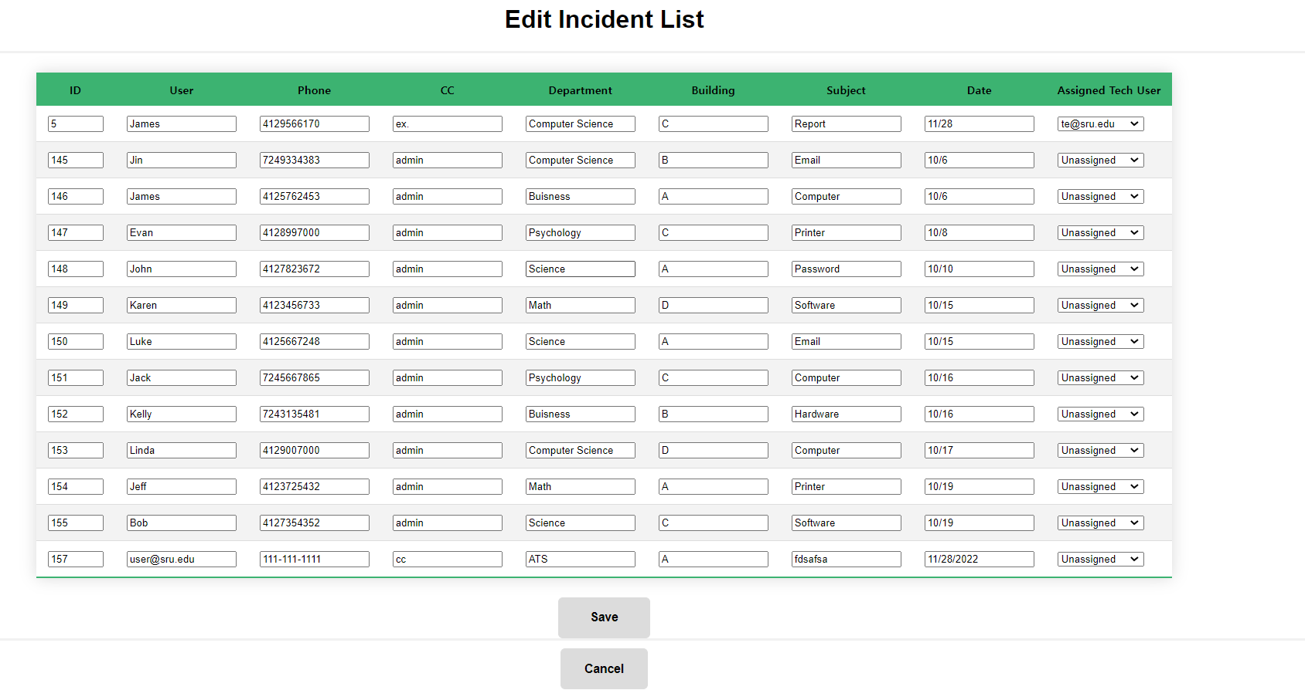

* 1. Change the Assigned Tech User

When you create the technical account, you need to assign to your technical account.

1.4 when you're done choosing, press Save to save.

Go back to your Login Tab, and sign in to technical account.

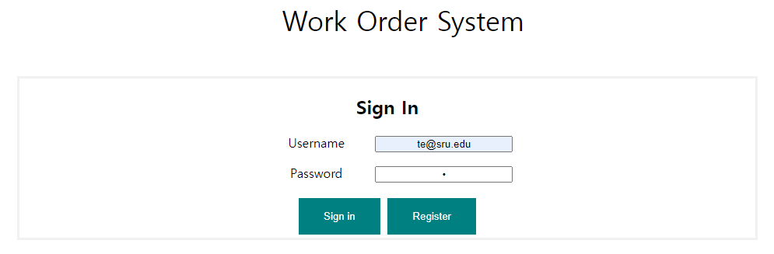

* 1. Go to the Assigned incidents.

If you want to edit incident, you can edit and change the Status.

1.5When you want to check progressing your request, login to user account. And go to My incident

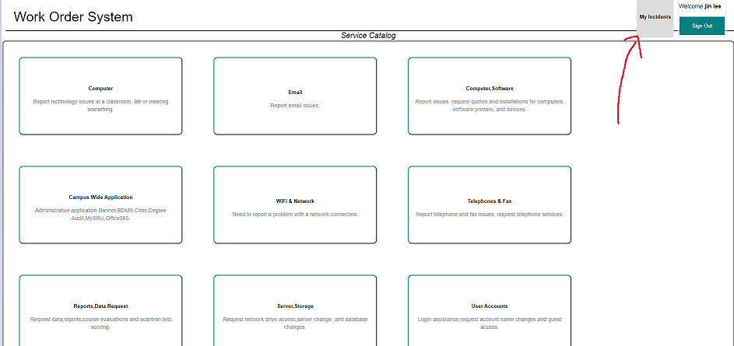

Then, you can see your incident status.

